Welcome to Child Care Seer!
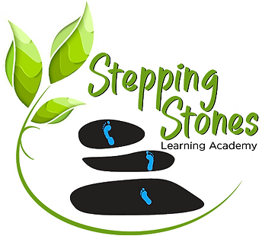
Stepping Stones Learning Academy has chosen Child Care SeerTM to automate everything with child care except their love of children! Soon you will have direct and easy access to your child's billing, attendance, documents, and schedule. You'll be able to use our contactless kiosk, request schedule changes, set up and change payments, communicate with staff and so much more! We wanted to take a moment to give you some details about what to expect from this all-in-one child care software experience. Right now, we’re working hard to set up the new software, and we are planning to launch Seer on
Information Validation
One of the many advantages of Child Care Seer is that it allows parents to access and update their child’s profile information as needed, without having to stop at the front desk. As a first step, Stepping Stones Learning Academy will soon send you an email with a link to add or confirm your child’s profile information. This includes contact information for all adults on your account as well as emergency contacts for your child. You do not need a Child Care Seer account to access this link.
Invitation to Parent Portal
Prior to launch, you will receive an email inviting you to join Child Care Seer. Creating an account will allow you to view your child’s information via browser on desktop or your mobile device…there is no app to download! From your account, you can pay your bill, set up and manage autopayments, load your prepaid account, request an hourly visit, enroll in a new program, upload necessary documents, download tax receipts and so much more!
Kiosk PIN
Starting on launch day, you will be able to check your child in and out using the Child Care Seer Kiosk. Each adult at Stepping Stones Learning Academy will have a unique 6-digit PIN to help keep your child safe. If you forget your PIN, you can access it on the Parent Portal or check with the front desk.
When you enter your PIN, you’ll be able to select which of your children to check in. Please be sure to push the blue check-in button to record your entry and click Finish when done.
If Stepping Stones Learning Academy has enabled the contactless kiosk, you can use your phone to check-in by using your camera to capture the QR code on the kiosk. Simply click the link and enter your PIN on your phone, select your child(ren) and click the blue check-in button.
Please note, if you have an outstanding balance at Stepping Stones Learning Academy, you may be unable to use the kiosk for check-in or check-out per daycare policy, and you will need to visit the front desk for check-in.

Need Help?
If you have any questions about Child Care Seer, feel free to ask at Stepping Stones Learning Academy’s front desk or check out our training resources at www.childcareseer.com/resources

